**Code List**

**Employment Tasks**

1= Produces final goods/provides services

2 = General Management

3 = Purchase of inputs

4 = Delivery of products

5 = Accounts/finances

6 = Sales

7 = Marketing

8 = Sundry Errands

9 = Other, specify: __________________________

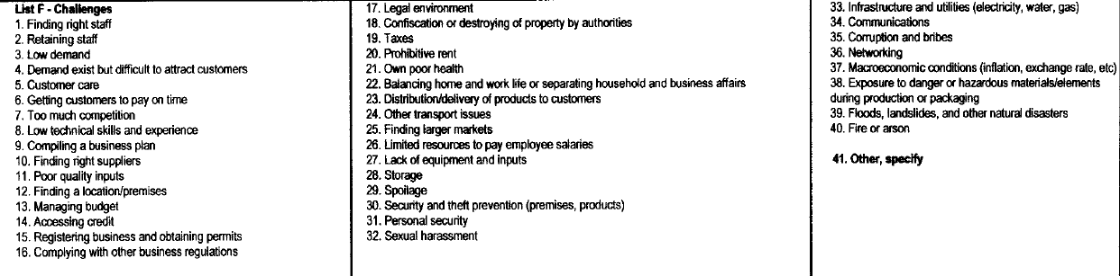

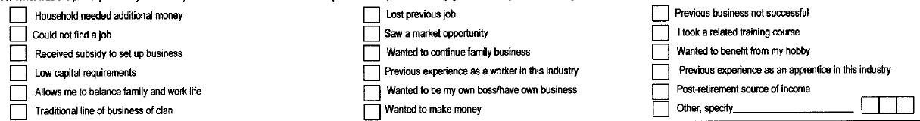

|  |  |  |  |
| --- | --- | --- | --- |
| **Sector_**  **Category** | **Sector_name** | **Sector**  **_Code** | **Notes/examples** |
| Manufacturing | Textile and garment manufacturing | 01 |  |
|  | Leather and leather products manufa. | 02 |  |
|  | Intermediate food/beverage products production | 03 | flour/milling, shiro powder, roasted barley, berbere, injera etc |
|  | Metal works and engineering | 04 | windows, fixtures, metal furniture etc |
|  | Wood works | 05 | furniture, ornaments, etc |
|  | Building materials manufacturing | 06 | crushing stones, quarry work, making bricks, cobble stones, ceramics |
|  | Gemstone and jewelry production | 07 |  |
| Construction | Contracting or subcontracting for construction works | 08 | Including both public and private construction projects |
| Trade | Wholesale | 09 | Of imported or domestic products |
|  | Retail | 10 |  |
| Service | Small transport services | 11 |  |
|  | Café and restaurants | 12 |  |
|  | Storage and warehousing services | 13 |  |
|  | Tourism services | 14 |  |
|  | Canning/packing services | 15 |  |
|  | Business services | 16 | Printing/photocopying, secretarial services, management consulting etc |
|  | Staffing/outsourcing services | 17 |  |
|  | Engineering services | 18 |  |
|  | Municipal services | 19 | wet or dry waste collection, parking, etc |
|  | Automobile maintenance | 20 |  |
|  | Maintenance services (non-automobile) | 21 | maintenance of buildings, electronics, equipment, etc |
|  | Equipment leasing services | 22 | electronic, agricultural, construction, etc |
|  | Beauty salon | 23 |  |
|  | Software dev’t/web design services | 24 |  |
|  | Interior design/decorating services | 25 |  |
|  | Communications services | 26 | Internet café, phone charging, etc |
|  | Cleaning services (non-laundry) | 27 |  |
|  | Laundry services | 28 |  |
| Agriculture | Modern livestock rearing | 29 | including fattening for dairy products |
|  | Beekeeping | 30 |  |
|  | Poultry | 31 |  |
|  | Seedlings | 32 |  |
|  | Vegetables and fruits | 33 |  |
|  | Animal feed production | 34 |  |
| Other | Other | 35 |  |

